**Zadaća 4 iz Diskretne matematike**

Amar Terović, **17395**

Grupa: RI-5

Demonstrator: Amila Jakubović

**ZADATAK 1**

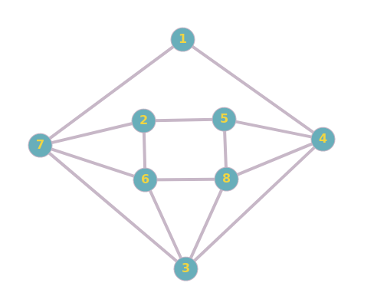  
graf 1

**a)**

L1 = {{x4, x7}, {x5, x6, x7}, {x4, x6, x7, x8}, {x1, x3 , x5, x8}, {x2, x4 , x8}, {x2, x3, x7, x8},

{x1, x2, x3, x6}, {x3, x4, x5, x6}}

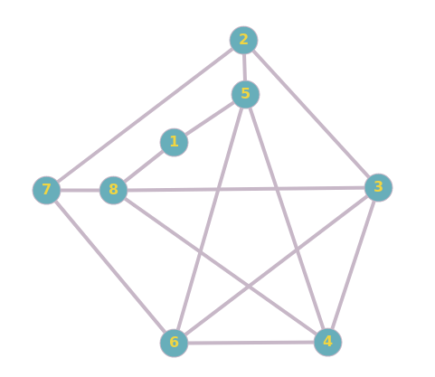  
graf 2

L2 = {{x5, x8}, {x3, x5, x7}, {x2, x4, x6, x8}, {x3, x5, x6, x8}, {x1, x2, x4, x6}, {x3, x4, x5, x7},

{x2, x6, x8}, {x1, x3, x4, x7}}

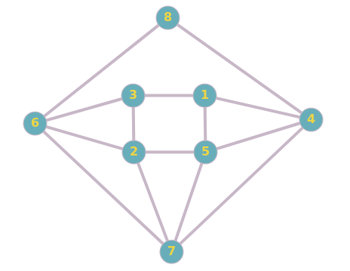  
graf 3

L3 = {{x3, x4, x5}, {x3, x5, x6, x7}, {x1, x2, x6}, {x1, x5, x7, x8}, {x1, x2, x4, x7}, {x2, x3, x7, x8}, {x2, x4, x5, x6}, {x4, x6}}

**b)**

Sva 3 grafa imaju po 8 čvorova i po 14 grana. Graf 1 ima 1 čvor stepena 2, 2 čvora stepena 3 i 5 čvorova stepena 4, baš kao i grafovi 2 i 3. Međutim, **izomorfni su samo grafovi 1 i 3.** Pogodnim crtanjem prikazanim na prethodnoj stranici, lahko je uočiti da se pomenuti grafovi razlikuju samo u obilježavanju čvorova. Naime, počevši od grafa 1 dobit ćemo graf 3 sljedećom promjenom obilježavanja čvorova: **x1 -> x8, x8 -> x5, x5 -> x1, x2 -> x3, x3 -> x7, x7 -> x6,**

**x6 -> x2.** Graf 2 nije planaran (što će se dokazati u dijelu pod c) tako da ne može biti izomorfan sa grafovima 1 i 3 koji su planarni.

**c)**

**Grafovi 1 i 3 su planarni,** te se mogu nacrtati tako da im se grane ne presijecaju što je prikazano na prethodnoj stranici. **Graf 2 nije planaran** jer ga je moguće svesti na graf K5 primijenjujući, recimo, Wagnerovu teoremu. Izvršit ćemo redom kontrakcije duž ivica {x7, x8}, {x2, x5}, {x1, x5}. Opisani postupak je prikazan na slikama ispod:

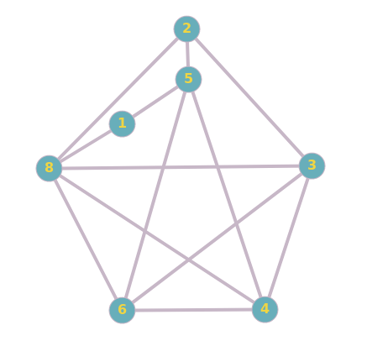

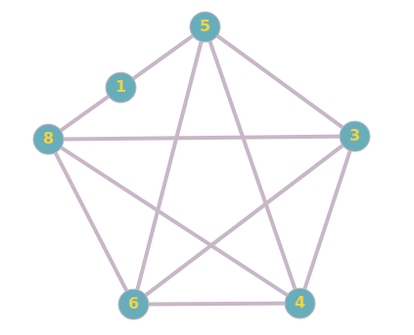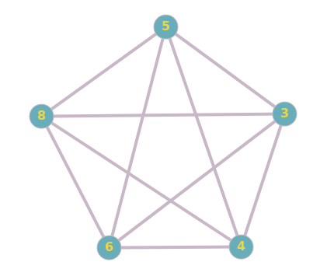

**d)**

**Što se tiče grafa 2**, pohlepni algoritam daje optimalno bojenje. Zaista, uzevši u obzir da graf 2 sadrži graf K3  kao podgraf(npr. graf koji obrazuju grane {x4, x5}, {x5, x6}, {x6, x4}), minimalan broj boja potrebnih za ispravno bojenje je 3. Kako smo primjenom pohlepnog algoritma u rastućem poretku čvorova počevši od x1 ustanovili da su potrebne 3 boje, to je i **hromatski broj grafa jednak 3**. Bojenje je prikazano na slici ispod, pri čemu je korišten skup boja {crvena, plava, zelena}.

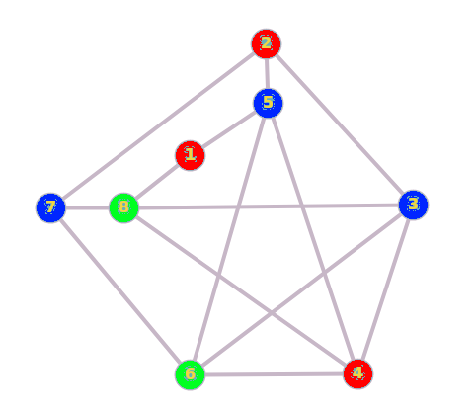

**Razmotrimo sada graf 1**. Pohlepni algoritam daje ispravno bojenje koje podrazumijeva 4 boje. Provjerimo sada da li je to i minimalan broj boja potrebnih za ispravno bojenje. Počnimo od podgrafa K3 kojeg obrazuju čvorovi 3, 6 i 8. Za njihovo bojenje moramo iskoristiti 3 boje, pa ćemo ih obojiti u crvenu, plavu i zelenu respektivno.

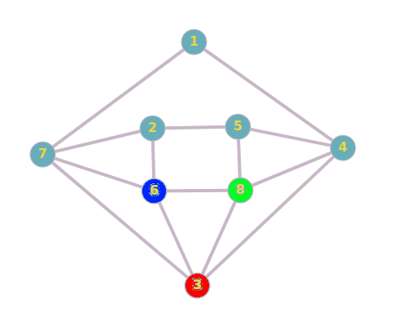

Sada čvorove 7 i 4 moramo obojiti u zelenu, odnosno plavu boju.

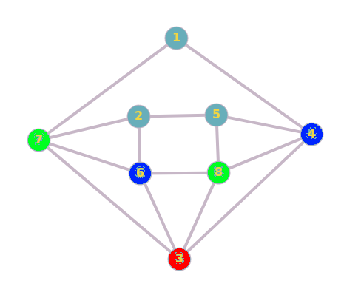

Kako čvorovi 2 i 5 imaju po jednog zelenog i po jednog plavog susjeda, oba čvora bismo morali obojiti u crvenu boju ako želimo da bojenje izvedemo sa 3 boje. Međutim, to nije moguće izvesti jer su 2 i 5 susjedni čvorovi, tako da najviše jednog od njih možemo obojiti u crvenu boju pa neka to bude, recimo, čvor 2. Čvor 5 sada moramo obojiti nekom novom bojom, npr. žutom. Ovim smo pokazali da je minimalan broj boja koje moramo iskoristiti za ispravno bojenje ovog grafa 4, stoga je traženi **hromatski broj ovog grafa jednak 4**. Preostaje nam još čvor 1 kojeg možemo obojiti u crvenu boju. Bojenje čvorova ovog grafa prikazano je na slici ispod.

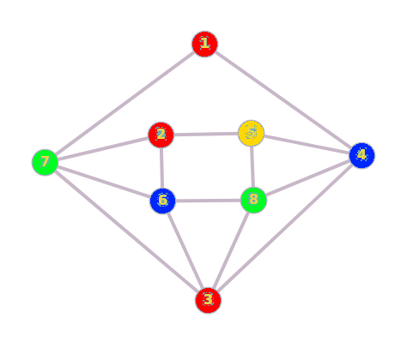

**Za graf 3** vrijedi isto rezonovanje kao i za graf 1 jer su oni izomorfni.

**ZADATAK 2**

**a)**

|  |  |  |  |  |  |  |  |  |  |  |  |  |  |  |
| --- | --- | --- | --- | --- | --- | --- | --- | --- | --- | --- | --- | --- | --- | --- |
| **Grana** | **Težina** | **Uzeti** | **c1** | **c2** | **c3** | **c4** | **c5** | **c6** | **c7** | **c8** | **c9** | **c10** | **c11** | **c12** |
| {L10, L12} | 270 | da |  |  |  |  |  |  |  |  |  | 1 |  | 1 |
| {L7, L11} | 330 | da |  |  |  |  |  |  | 2 |  |  |  | 2 |  |
| {L5, L10} | 420 | da |  |  |  |  | 1 |  |  |  |  |  |  |  |
| {L4, L5} | 460 | da |  |  |  | 1 |  |  |  |  |  |  |  |  |
| {L3, L12} | 510 | da |  |  | 1 |  |  |  |  |  |  |  |  |  |
| {L3, L9} | 550 | da |  |  |  |  |  |  |  |  | 1 |  |  |  |
| {L6, L11} | 550 | da |  |  |  |  |  | 2 |  |  |  |  |  |  |
| {L4, L12} | 580 | ne |  |  |  |  |  |  |  |  |  |  |  |  |
| {L3, L10} | 600 | ne |  |  |  |  |  |  |  |  |  |  |  |  |
| {L5, L12} | 600 | ne |  |  |  |  |  |  |  |  |  |  |  |  |
| {L1, L5} | 610 | da | 1 |  |  |  |  |  |  |  |  |  |  |  |
| {L6, L7} | 700 | ne |  |  |  |  |  |  |  |  |  |  |  |  |
| {L2, L9} | 750 | da |  | 1 |  |  |  |  |  |  |  |  |  |  |
| {L9, L10} | 780 | ne |  |  |  |  |  |  |  |  |  |  |  |  |
| {L5, L6} | 790 | da |  |  |  |  |  | 1 | 1 |  |  |  | 1 |  |
| {L5, L9} | 850 | ne |  |  |  |  |  |  |  |  |  |  |  |  |
| {L11, L12} | 880 | ne |  |  |  |  |  |  |  |  |  |  |  |  |
| {L10, L11} | 1080 | ne |  |  |  |  |  |  |  |  |  |  |  |  |
| {L2, L12} | 1130 | ne |  |  |  |  |  |  |  |  |  |  |  |  |
| {L5, L7} | 1300 | ne |  |  |  |  |  |  |  |  |  |  |  |  |
| {L7, L8} | 1300 | da |  |  |  |  |  |  |  | 1 |  |  |  |  |
| {L1, L6} | 1310 | ne |  |  |  |  |  |  |  |  |  |  |  |  |
| {L1, L8} | 1310 | ne |  |  |  |  |  |  |  |  |  |  |  |  |
| {L2, L4} | 1370 | ne |  |  |  |  |  |  |  |  |  |  |  |  |
| {L4, L8} | 1380 | ne |  |  |  |  |  |  |  |  |  |  |  |  |

Računarska mreža, takva da je utrošak kablova minimalan, podrazumijava povezivanje sljedećih lokacija: **L1 – L5, L2 – L9, L3 – L9, L3 – L12, L4 – L5, L5, - L6, L5 – L10, L6 – L11, L7 – L8, L7 – L11, L10 – L12,** a za to je potrebno je **6540** metara kabla.

**b)**

|  |  |  |  |  |  |  |  |  |  |  |  |  |  |  |
| --- | --- | --- | --- | --- | --- | --- | --- | --- | --- | --- | --- | --- | --- | --- |
| **Grana** | **Težina** | **Uzeti** | **x1/1** | **x2/1** | **x3/1** | **x4/1** | **x5/1** | **x6/1** | **x7/1** | **x8/1** | **x9/1** | **x10/1** | **x11/1** | **x12/1** |
| {L10, L12} | 270 | da |  |  |  |  |  |  |  |  |  | x10/2 |  | x10/1 |
| {L7, L11} | 330 | da |  |  |  |  |  |  | x7/2 |  |  |  | x7/1 |  |
| {L5, L10} | 420 | da |  |  |  |  | x10/1 |  |  |  |  | x10/3 |  |  |
| {L4, L5} | 460 | da |  |  |  | x10/1 |  |  |  |  |  | x10/4 |  |  |
| {L3, L12} | 510 | da |  |  | x10/1 |  |  |  |  |  |  | x10/5 |  |  |
| {L3, L9} | 550 | da |  |  |  |  |  |  |  |  | x10/1 | x10/6 |  |  |
| {L6, L11} | 550 | da |  |  |  |  |  | x7/1 | x7/3 |  |  |  |  |  |
| {L4, L12} | 580 | ne |  |  |  |  |  |  |  |  |  |  |  |  |
| {L3, L10} | 600 | ne |  |  |  |  |  |  |  |  |  |  |  |  |
| {L5, L12} | 600 | ne |  |  |  |  |  |  |  |  |  |  |  |  |
| {L1, L5} | 610 | da | x10/1 |  |  |  |  |  |  |  |  | x10/7 |  |  |
| {L6, L7} | 700 | ne |  |  |  |  |  |  |  |  |  |  |  |  |
| {L2, L9} | 750 | da |  | x10/1 |  |  |  |  |  |  |  | x10/8 |  |  |
| {L9, L10} | 780 | ne |  |  |  |  |  |  |  |  |  |  |  |  |
| {L5, L6} | 790 | da |  |  |  |  |  |  | x10/3 |  |  | x10/11 |  |  |
| {L5, L9} | 850 | ne |  |  |  |  |  |  |  |  |  |  |  |  |
| {L11, L12} | 880 | ne |  |  |  |  |  |  |  |  |  |  |  |  |
| {L10, L11} | 1080 | ne |  |  |  |  |  |  |  |  |  |  |  |  |
| {L2, L12} | 1130 | ne |  |  |  |  |  |  |  |  |  |  |  |  |
| {L5, L7} | 1300 | ne |  |  |  |  |  |  |  |  |  |  |  |  |
| {L7, L8} | 1300 | da |  |  |  |  |  |  |  | x10/1 |  | x10/12 |  |  |
| {L1, L6} | 1310 | ne |  |  |  |  |  |  |  |  |  |  |  |  |
| {L1, L8} | 1310 | ne |  |  |  |  |  |  |  |  |  |  |  |  |
| {L2, L4} | 1370 | ne |  |  |  |  |  |  |  |  |  |  |  |  |
| {L4, L8} | 1380 | ne |  |  |  |  |  |  |  |  |  |  |  |  |

Primjenom Kruskalovog algoritma dobili smo isti rezultat kao u slučaju pod a.

**c)**

Težinska matrica ovog grafa izgleda ovako:

$$W = \left(\begin{matrix}0 & ∞ & ∞ & ∞ & 610 & 1310 & ∞ & 1310 & ∞ & ∞ & ∞ & ∞ \\ ∞ & 0 & ∞ & 1370 & ∞ & ∞ & ∞ & ∞ & 750 & ∞ & ∞ & 1130 \\ ∞ & ∞ & 0 & ∞ & ∞ & ∞ & ∞ & ∞ & 550 & 600 & ∞ & 510 \\ ∞ & 1370 & ∞ & 0 & 460 & ∞ & ∞ & 1380 & ∞ & ∞ & ∞ & 580 \\ 610 & ∞ & ∞ & 460 & 0 & 790 & 1300 & ∞ & 850 & 420 & ∞ & 600 \\ 1310 & ∞ & ∞ & ∞ & 790 & 0 & 700 & ∞ & ∞ & ∞ & 550 & ∞ \\ ∞ & ∞ & ∞ & ∞ & 1300 & 700 & 0 & 1300 & ∞ & ∞ & 330 & ∞ \\ 1310 & ∞ & ∞ & 1380 & ∞ & ∞ & 1300 & 0 & ∞ & ∞ & ∞ & ∞ \\ ∞ & 750 & 550 & ∞ & 850 & ∞ & ∞ & ∞ & 0 & 780 & ∞ & ∞ \\ ∞ & ∞ & 600 & ∞ & 420 & ∞ & ∞ & ∞ & 780 & 0 & 1080 & 270 \\ ∞ & ∞ & ∞ & ∞ & ∞ & 550 & 330 & ∞ & ∞ & 1080 & 0 & 880 \\ ∞ & 1130 & 510 & 580 & 600 & ∞ & ∞ & ∞ & ∞ & 270 & 880 & 0\end{matrix}\right)$$

Sada je lahko prikazati tok Primovog algoritma u tabelarnoj formi: (težine grana su podijeljene sa 10 zbog lakšeg unosa u tabelu)

|  |  |  |  |  |  |  |  |  |  |  |  |  |
| --- | --- | --- | --- | --- | --- | --- | --- | --- | --- | --- | --- | --- |
| **Novi**  **čvor** | **L1** | **L2** | **L3** | **L4** | **L5** | **L6** | **L7** | **L8** | **L9** | **L10** | **L11** | **L12** |
| **0** | - | - | - | - | - | - | - | - | - | - | - |
| L1 |  | - | - | - | **61/L1** | 131/L1 | - | 131/L1 | - | - | - | - |
| L5 |  | - | - | 46/L5 |  | 79/L5 | 130/L5 | 131/L1 | 85/L5 | **42/L5** | - | - |
| L10 |  | - | 60/L10 | 46/L5 |  | 79/L5 | 130/L5 | 131/L1 | 78/L10 |  | 108/L10 | **27/L10** |
| L12 |  | 113/L12 | **51/L12** | 46/L5 |  | 79/L5 | 130/L5 | 131/L1 | 78/L10 |  | 88/L12 |  |
| L3 |  | 113/L12 |  | **46/L5** |  | 79/L5 | 130/L5 | 131/L1 | 55/L3 |  | 88/L12 |  |
| L4 |  | 113/L12 |  |  |  | 79/L5 | 130/L5 | 131/L1 | **55/L3** |  | 88/L12 |  |
| L9 |  | **75/L9** |  |  |  | 79/L5 | 130/L5 | 131/L1 |  |  | 88/L12 |  |
| L2 |  |  |  |  |  | **79/L5** | 130/L5 | 131/L1 |  |  | 88/L12 |  |
| L6 |  |  |  |  |  |  | 70/L6 | 131/L1 |  |  | **55/L6** |  |
| L11 |  |  |  |  |  |  | **33/L11** | 131/L1 |  |  |  |  |
| L7 |  |  |  |  |  |  |  | **130/L7** |  |  |  |  |
| L8 |  |  |  |  |  |  |  |  |  |  |  |  |

Konačno, upotrebom Primovog algoritma dobili smo isti rezultat kao u slučajevima a i b.

**ZADATAK 3**

Težinska matrica grafa izgleda ovako:

$$W = \left(\begin{matrix}0 & 700 & 1070 & ∞ & 1190 & 200 & 1270 & 380 \\ 700 & 0 & 560 & 200 & 1360 & ∞ & ∞ & 1380 \\ 1070 & 560 & 0 & 410 & 750 & 310 & 1340 & 430 \\ ∞ & 200 & 410 & 0 & 1500 & 410 & 890 & 710 \\ 1190 & 1360 & 750 & 1500 & 0 & 400 & 1070 & 1020 \\ 200 & ∞ & 310 & 410 & 400 & 0 & 1270 & ∞ \\ 1270 & ∞ & 1340 & 890 & 1070 & 1270 & 0 & 470 \\ 380 & 1380 & 430 & 710 & 1020 & ∞ & 470 & 0\end{matrix}\right)$$

Sada ćemo Dijkstrinim algoritmom naći najjeftinije načine transporta iz svakog od datih 8 gradova do svih ostalih datih gradova.

|  |  |  |  |  |  |  |  |  |
| --- | --- | --- | --- | --- | --- | --- | --- | --- |
| **Novi**  **čvor** | **La** | **Qu** | **Pt** | **Om** | **So** | **Re** | **Ox** | **Ur** |
| **0** | - | - | - | - | - | - | - |
| La(0) |  | 700/La | 1070/La | - | 1190/La | **200/La** | 1270/La | 380/La |
| Re(200) |  | 700/La | 510/Re | 610/Re | 600/Re |  | 1270/La | **380/La** |
| Ur(380) |  | 700/La | **510/Re** | 610/Re | 600/Re |  | 850/Ur |  |
| Pt(510) |  | 700/La |  | 610/Re | **600/Re** |  | 850/Ur |  |
| So(600) |  | 700/La |  | **610/Re** |  |  | 850/Ur |  |
| Om(610) |  | **700/La** |  |  |  |  | 850/Ur |  |
| Qu(700) |  |  |  |  |  |  | **850/Ur** |  |
| Ox(850) |  |  |  |  |  |  |  |  |

|  |  |  |  |  |  |  |  |  |
| --- | --- | --- | --- | --- | --- | --- | --- | --- |
| **Novi**  **čvor** | **La** | **Qu** | **Pt** | **Om** | **So** | **Re** | **Ox** | **Ur** |
| - | **0** | - | - | - | - | - | - |
| Qu(0) | 700/Qu |  | 560/Qu | **200/Qu** | 1360/Qu | - | - | 1380/Qu |
| Om(200) | 700/Qu |  | **560/Qu** |  | 1360/Qu | 610/Om | 1090/Om | 910/Om |
| Pt(560) | 700/Qu |  |  |  | 1310/Pt | **610/Om** | 1090/Om | 910/Om |
| Re(610) | **700/Qu** |  |  |  | 1010/Re |  | 1090/Om | 910/Om |
| La(700) |  |  |  |  | 1010/Re |  | 1090/Om | **910/Om** |
| Ur(910) |  |  |  |  | **1010/Re** |  | 1090/Om |  |
| So(1010) |  |  |  |  |  |  | **1090/Om** |  |
| Ox(1090) |  |  |  |  |  |  |  |  |

|  |  |  |  |  |  |  |  |  |
| --- | --- | --- | --- | --- | --- | --- | --- | --- |
| **Novi**  **čvor** | **La** | **Qu** | **Pt** | **Om** | **So** | **Re** | **Ox** | **Ur** |
| - | - | **0** | - | - | - | - | - |
| Pt(0) | 1070/Pt | 560/Pt |  | 410/Pt | 750/Pt | **310/Pt** | 1340/Pt | 430/Pt |
| Re(310) | 510/Re | 560/Pt |  | **410/Pt** | 710/Re |  | 1340/Pt | 430/Pt |
| Om(410) | 510/Re | 560/Pt |  |  | 710/Re |  | 1300/Om | **430/Pt** |
| Ur(430) | **510/Re** | 560/Pt |  |  | 710/Re |  | 900/Ur |  |
| La(510) |  | **560/Pt** |  |  | 710/Re |  | 900/Ur |  |
| Qu(560) |  |  |  |  | **710/Re** |  | 900/Ur |  |
| So(710) |  |  |  |  |  |  | **900/Ur** |  |
| Ox(900) |  |  |  |  |  |  |  |  |

|  |  |  |  |  |  |  |  |  |
| --- | --- | --- | --- | --- | --- | --- | --- | --- |
| **Novi**  **čvor** | **La** | **Qu** | **Pt** | **Om** | **So** | **Re** | **Ox** | **Ur** |
| - | - | - | **0** | - | - | - | - |
| Om(0) | - | **200/Om** | 410/Om |  | 1500/Om | 410/Om | 890/Om | 710/Om |
| Qu(200) | 900/Qu |  | **410/Om** |  | 1500/Om | 410/Om | 890/Om | 710/Om |
| Pt(410) | 900/Qu |  |  |  | 1160/Pt | **410/Om** | 890/Om | 710/Om |
| Re(410) | **610/Re** |  |  |  | 810/Re |  | 890/Om | 710/Om |
| La(610) |  |  |  |  | 810/Re |  | 890/Om | **710/Om** |
| Ur(710) |  |  |  |  | **810/Re** |  | 890/Om |  |
| So(810) |  |  |  |  |  |  | **890/Om** |  |
| Ox(890) |  |  |  |  |  |  |  |  |

|  |  |  |  |  |  |  |  |  |
| --- | --- | --- | --- | --- | --- | --- | --- | --- |
| **Novi**  **čvor** | **La** | **Qu** | **Pt** | **Om** | **So** | **Re** | **Ox** | **Ur** |
| - | - | - | - | **0** | - | - | - |
| So(0) | 1190/So | 1360/So | 750/So | 1500/So |  | **400/So** | 1070/So | 1020/So |
| Re(400) | **600/Re** | 1360/So | 710/Re | 810/Re |  |  | 1070/So | 1020/So |
| La(600) |  | 1300/La | **710/Re** | 810/Re |  |  | 1070/So | 980/La |
| Pt(710) |  | 1270/Pt |  | **810/Re** |  |  | 1070/So | 980/La |
| Om(810) |  | 1010/Om |  |  |  |  | 1070/So | **980/La** |
| Ur(980) |  | **1010/Om** |  |  |  |  | 1070/So |  |
| Qu(1010) |  |  |  |  |  |  | **1070/So** |  |
| Ox(1070) |  |  |  |  |  |  |  |  |

|  |  |  |  |  |  |  |  |  |
| --- | --- | --- | --- | --- | --- | --- | --- | --- |
| **Novi**  **čvor** | **La** | **Qu** | **Pt** | **Om** | **So** | **Re** | **Ox** | **Ur** |
| - | - | - | - | - | **0** | - | - |
| Re(0) | **200/Re** | - | 310/Re | 410/Re | 400/Re |  | 1270/Re | - |
| La(200) |  | 900/La | **310/Re** | 410/Re | 400/Re |  | 1270/Re | 580/La |
| Pt(310) |  | 870/Pt |  | 410/Re | **400/Re** |  | 1270/Re | 580/La |
| So(400) |  | 870/Pt |  | **410/Re** |  |  | 1270/Re | 580/La |
| Om(410) |  | 610/Om |  |  |  |  | 1270/Re | **580/La** |
| Ur(580) |  | **610/Om** |  |  |  |  | 1050/Ur |  |
| Qu(610) |  |  |  |  |  |  | **1050/Ur** |  |
| Ox(1050) |  |  |  |  |  |  |  |  |

|  |  |  |  |  |  |  |  |  |
| --- | --- | --- | --- | --- | --- | --- | --- | --- |
| **Novi**  **čvor** | **La** | **Qu** | **Pt** | **Om** | **So** | **Re** | **Ox** | **Ur** |
| - | - | - | - | - | - | **0** | - |
| Ox(0) | 1270/Ox | - | 1340/Ox | 890/Ox | 1070/Ox | 1270/Ox |  | **470/Ox** |
| Ur(470) | **850/Ur** | 1850/Ur | 900/Ur | 890/Ox | 1070/Ox | 1270/Ox |  |  |
| La(850) |  | 1550/La | 900/Ur | **890/Ox** | 1070/Ox | 1050/La |  |  |
| Om(890) |  | 1090/Om | **900/Ur** |  | 1070/Ox | 1050/La |  |  |
| Pt(900) |  | 1090/Om |  |  | 1070/Ox | **1050/La** |  |  |
| Re(1050) |  | 1090/Om |  |  | **1070/Ox** |  |  |  |
| So(1070) |  | **1090/Om** |  |  |  |  |  |  |
| Qu(1090) |  |  |  |  |  |  |  |  |

|  |  |  |  |  |  |  |  |  |
| --- | --- | --- | --- | --- | --- | --- | --- | --- |
| **Novi**  **čvor** | **La** | **Qu** | **Pt** | **Om** | **So** | **Re** | **Ox** | **Ur** |
| - | - | - | - | - | - | - | **0** |
| Ur(0) | **380/Ur** | 1380/Ur | 430/Ur | 710/Ur | 1020/Ur | - | 470/Ur |  |
| La(380) |  | 1080/La | **430/Ur** | 710/Ur | 1020/Ur | 580/La | 470/Ur |  |
| Pt(430) |  | 990/Pt |  | 710/Ur | 1020/Ur | 580/La | **470/Ur** |  |
| Ox(470) |  | 990/Pt |  | 710/Ur | 1020/Ur | **580/La** |  |  |
| Re(580) |  | 990/Pt |  | **710/Ur** | 980/Re |  |  |  |
| Om(710) |  | **910/Om** |  |  | 980/Re |  |  |  |
| Qu(910) |  |  |  |  | **980/Re** |  |  |  |
| So(980) |  |  |  |  |  |  |  |  |

Slijedi tablica koja sadrži informacije koliko iznose najjeftinije cijene aviotransporta (u tabeli su prikazana i eventualna presjedanja):

|  |  |  |  |  |  |  |  |  |
| --- | --- | --- | --- | --- | --- | --- | --- | --- |
|  | **Lamgu** | **Quwuti** | **Ptorwur** | **Omacodi** | **Sosyab** | **Rekazga** | **Oxat** | **Urasoto** |
| **Lamgu** | 0 | **700** | Rekazga  **510** | Rekazga  **610** | Rekazga  **600** | **200** | Urasoto  **850** | **380** |
| **Quwuti** | **700** | 0 | **560** | **200** | Omacodi  Rekazga  **1010** | Omacodi  **610** | Omacodi  **1090** | Omacodi  **910** |
| **Ptorwur** | Rekazga  **510** | **560** | 0 | **410** | Rekazga  **710** | **310** | Urasoto  **900** | **430** |
| **Omacodi** | Rekazga  **610** | **200** | **410** | 0 | Rekazga  **810** | **410** | **890** | **710** |
| **Sosyab** | Rekazga  **600** | Omacodi  Rekazga  **1010** | Rekazga  **710** | Rekazga  **810** | 0 | **400** | **1070** | Rekazga  Lamgu  **980** |
| **Rekazga** | **200** | Omacodi  **610** | **310** | **410** | **400** | 0 | Lamgu  Urasoto  **1050** | Lamgu  **580** |
| **Oxat** | Urasoto  **850** | Omacodi  **1090** | Urasoto  **900** | **890** | **1070** | Lamgu  Urasoto  **1050** | 0 | **470** |
| **Urasoto** | **380** | Omacodi  **910** | **430** | **710** | Rekazga  Lamgu  **980** | Lamgu  **580** | **470** | 0 |

**ZADATAK 4**

$W = \left(\begin{matrix}∞ & 36 & ∞ & 27 & ∞ & ∞ & ∞ & ∞ & ∞ & ∞ \\ ∞ & ∞ & 30 & ∞ & -18 & ∞ & ∞ & 24 & ∞ & ∞ \\ 42 & ∞ & ∞ & ∞ & ∞ & ∞ & ∞ & ∞ & ∞ & ∞ \\ ∞ & -57 & ∞ & ∞ & ∞ & ∞ & ∞ & ∞ & ∞ & ∞ \\ ∞ & ∞ & ∞ & ∞ & ∞ & 39 & 45 & ∞ & ∞ & 33 \\ 36 & ∞ & ∞ & ∞ & ∞ & ∞ & ∞ & -63 & ∞ & ∞ \\ 12 & ∞ & ∞ & ∞ & ∞ & ∞ & ∞ & ∞ & ∞ & ∞ \\ ∞ & ∞ & ∞ & ∞ & ∞ & ∞ & 39 & ∞ & ∞ & ∞ \\ ∞ & ∞ & ∞ & ∞ & -51 & 15 & ∞ & ∞ & ∞ & ∞ \\ ∞ & ∞ & -39 & ∞ & ∞ & 48 & ∞ & ∞ & ∞ & ∞\end{matrix}\right)$ Težinska matrica datog grafa

Bellman-Fordov algoritam započinjemo iz čvora “I” budući da je on izvor (njegov ulazni stepen je 0), što možemo zaključiti posmatrajući pretposljednju kolonu težinske matrice. Provjerimo da li algoritam terminira nakon najviše 10 iteracija:

**1. iteracija**

|  |  |  |  |  |  |  |  |  |  |  |  |
| --- | --- | --- | --- | --- | --- | --- | --- | --- | --- | --- | --- |
| **xi\xj** | **A** | **B** | **C** | **D** | **E** | **F** | **G** | **H** | **I** | **J** | **λi** |
| **∞** | **∞** | **∞** | **∞** | **∞** | **∞** | **∞** | **∞** | **0** | **∞** |
| I |  |  |  |  | **-51** | **15** |  |  |  |  | 0 |
| E |  |  |  |  |  | **-12** | **-6** |  |  | **-18** | ∞,-51 |
| G | **6** |  |  |  |  |  |  |  |  |  | ∞,-6,-36 |
| A |  | **42** |  | **33** |  |  |  |  |  |  | ∞,6 |
| D |  | **-24** |  |  |  |  |  |  |  |  | ∞,33 |
| B |  |  | **6** |  | -42 |  |  | **0** |  |  | ∞,42,-24 |
| C | 48 |  |  |  |  |  |  |  |  |  | ∞,6,-57 |
| F | 24 |  |  |  |  |  |  | **-75** |  |  | ∞,15,-12 |
| H |  |  |  |  |  |  | **-36** |  |  |  | ∞, 0,-75 |
| J |  |  | **-57** |  |  | 30 |  |  |  |  | ∞,-18 |

**2.iteracija**

|  |  |  |  |  |  |  |  |  |  |  |  |
| --- | --- | --- | --- | --- | --- | --- | --- | --- | --- | --- | --- |
| **xi\xj** | **A** | **B** | **C** | **D** | **E** | **F** | **G** | **H** | **I** | **J** | **λi** |
| **6** | **-24** | **-57** | **33** | **-51** | **-12** | **-36** | **-75** | **0** | **-18** |
| I |  |  |  |  | -51 | 15 |  |  |  |  | 0 |
| E |  |  |  |  |  | -12 | -6 |  |  | -18 | -51,-72 |
| G | **-24** |  |  |  |  |  |  |  |  |  | -36 |
| A |  | 12 |  | **3** |  |  |  |  |  |  | 6,-24 |
| D |  | **-54** |  |  |  |  |  |  |  |  | 33,3 |
| B |  |  | -24 |  | **-72** |  |  | -30 |  |  | -24,-54 |
| C | -15 |  |  |  |  |  |  |  |  |  | -57 |
| F | 24 |  |  |  |  |  |  | -75 |  |  | -12 |
| H |  |  |  |  |  |  | -36 |  |  |  | -75 |
| J |  |  | -57 |  |  | 30 |  |  |  |  | -18 |

**3. iteracija**

|  |  |  |  |  |  |  |  |  |  |  |  |
| --- | --- | --- | --- | --- | --- | --- | --- | --- | --- | --- | --- |
| **xi\xj** | **A** | **B** | **C** | **D** | **E** | **F** | **G** | **H** | **I** | **J** | **λi** |
| **-24** | **-54** | **-57** | **3** | **-72** | **-12** | **-36** | **-75** | **0** | **-18** |
| E |  |  |  |  |  | **-33** | -27 |  |  | **-39** | -72 |
| A |  | 12 |  | 3 |  |  |  |  |  |  | -24 |
| D |  | -54 |  |  |  |  |  |  |  |  | 3 |
| B |  |  | -24 |  | -72 |  |  | -30 |  |  | -54 |

**4. iteracija**

|  |  |  |  |  |  |  |  |  |  |  |  |
| --- | --- | --- | --- | --- | --- | --- | --- | --- | --- | --- | --- |
| **xi\xj** | **A** | **B** | **C** | **D** | **E** | **F** | **G** | **H** | **I** | **J** | **λi** |
| **-24** | **-54** | **-57** | **3** | **-72** | **-33** | **-36** | **-75** | **0** | **-39** |
| F | 3 |  |  |  |  |  |  | **-96** |  |  | -33 |
| J |  |  | **-78** |  |  | 9 |  |  |  |  | -39 |

**5. iteracija**

|  |  |  |  |  |  |  |  |  |  |  |  |
| --- | --- | --- | --- | --- | --- | --- | --- | --- | --- | --- | --- |
| **xi\xj** | **A** | **B** | **C** | **D** | **E** | **F** | **G** | **H** | **I** | **J** | **λi** |
| **-24** | **-54** | **-78** | **3** | **-72** | **-33** | **-36** | **-96** | **0** | **-39** |
| C | **-36** |  |  |  |  |  |  |  |  |  | -78 |
| H |  |  |  |  |  |  | **-57** |  |  |  | -96 |

**6. iteracija**

|  |  |  |  |  |  |  |  |  |  |  |  |
| --- | --- | --- | --- | --- | --- | --- | --- | --- | --- | --- | --- |
| **xi\xj** | **A** | **B** | **C** | **D** | **E** | **F** | **G** | **H** | **I** | **J** | **λi** |
| **-36** | **-54** | **-78** | **3** | **-72** | **-33** | **-57** | **-96** | **0** | **-39** |
| A |  | 0 |  | **-9** |  |  |  |  |  |  | -36 |
| G | **-45** |  |  |  |  |  |  |  |  |  | -57 |

**7. iteracija**

|  |  |  |  |  |  |  |  |  |  |  |  |
| --- | --- | --- | --- | --- | --- | --- | --- | --- | --- | --- | --- |
| **xi\xj** | **A** | **B** | **C** | **D** | **E** | **F** | **G** | **H** | **I** | **J** | **λi** |
| **-45** | **-54** | **-78** | **-9** | **-72** | **-33** | **-57** | **-96** | **0** | **-39** |
| A |  | -9 |  | **-18** |  |  |  |  |  |  | -45 |
| D |  | **-66** |  |  |  |  |  |  |  |  | -9 |

**8. iteracija**

|  |  |  |  |  |  |  |  |  |  |  |  |
| --- | --- | --- | --- | --- | --- | --- | --- | --- | --- | --- | --- |
| **xi\xj** | **A** | **B** | **C** | **D** | **E** | **F** | **G** | **H** | **I** | **J** | **λi** |
| **-45** | **-66** | **-78** | **-18** | **-72** | **-33** | **-57** | **-96** | **0** | **-39** |
| B |  |  | -36 |  | **-84** |  |  | -42 |  |  | -66 |
| D |  | **-75** |  |  |  |  |  |  |  |  | -18 |

**9. iteracija**

|  |  |  |  |  |  |  |  |  |  |  |  |
| --- | --- | --- | --- | --- | --- | --- | --- | --- | --- | --- | --- |
| **xi\xj** | **A** | **B** | **C** | **D** | **E** | **F** | **G** | **H** | **I** | **J** | **λi** |
| **-45** | **-75** | **-78** | **-18** | **-84** | **-33** | **-57** | **-96** | **0** | **-39** |
| B |  |  | -45 |  | **-93** |  |  | -51 |  |  | -75 |
| E |  |  |  |  |  | **-45** | -39 |  |  | **-51** | -84 |

**10. iteracija**

|  |  |  |  |  |  |  |  |  |  |  |  |
| --- | --- | --- | --- | --- | --- | --- | --- | --- | --- | --- | --- |
| **xi\xj** | **A** | **B** | **C** | **D** | **E** | **F** | **G** | **H** | **I** | **J** | **λi** |
| **-45** | **-75** | **-78** | **-18** | **-93** | **-45** | **-57** | **-96** | **0** | **-51** |
| E |  |  |  |  |  | **-54** | -48 |  |  | **-60** | -93 |
| F | -9 |  |  |  |  |  |  |  |  |  | -45 |
| J |  |  | **-90** |  |  | -3 |  |  |  |  | -51 |

Poznato je da Bellman-Fordov algoritam ne terminira nakon najviše n iteracija ako i samo ako u grafu postoji makar jedan ciklus negativne težine. Kako algoritam u ovom slučaju nije terminirao nakon 10 koraka, to je siguran znak da u grafu postoji barem jedan takav ciklus.

Primjeri takvih kontura: **F – H – G – A – D – B – E – F** ili **E – J – C – A – D – B – E.**

**ZADATAK 5**

Zbog činjenice da imamo 3 izvora, ovu transportnu mrežu ćemo svesti na klasičnu transportnu mrežu dodavanjem novog čvora S (superizvor), kao i grana koje spajaju superizvor sa izvorima. Pošto je njihova uloga čisto fiktivna, smatrat ćemo da imaju beskonačan kapacitet. Pošto krećemo od trivijalnog protoka, rezidualna matrica jednaka je težinskoj matrici.

S S1 S2 S3 R1 R2 R3 R4 R5 R6 R7 R8 K

|  |  |  |  |  |  |  |  |  |  |  |  |  |  |  |
| --- | --- | --- | --- | --- | --- | --- | --- | --- | --- | --- | --- | --- | --- | --- |
|  | **S** | **S1** | **S2** | **S3** | **R1** | **R2** | **R3** | **R4** | **R5** | **R6** | **R7** | **R8** | **K** | **dol.** |
| **S** | 0 | ∞ | ∞ | ∞ | 0 | 0 | 0 | 0 | 0 | 0 | 0 | 0 | 0 | -/0 |
| **S1** | 0 | 0 | 0 | 0 | 140 | 0 | 0 | 0 | 0 | 0 | 0 | 0 | 0 | S/1 |
| **S2** | 0 | 0 | 0 | 0 | 30 | 0 | 0 | 0 | 0 | 0 | 110 | 0 | 0 | S/1 |
| **S3** | 0 | 0 | 0 | 0 | 0 | 0 | 0 | 0 | 0 | 30 | 140 | 0 | 0 | S/1 |
| **R1** | 0 | 0 | 0 | 0 | 0 | 0 | 0 | 0 | 30 | 0 | 0 | 0 | 0 | S1/2 |
| **R2** | 0 | 0 | 0 | 0 | 0 | 0 | 100 | 60 | 0 | 0 | 0 | 0 | 0 | R6/3 |
| **R3** | 0 | 0 | 0 | 0 | 0 | 0 | 0 | 0 | 0 | 0 | 0 | 0 | **30** | R7/3 |
| **R4** | 0 | 0 | 0 | 0 | 0 | 0 | 0 | 0 | 0 | 0 | 0 | 0 | 60 | R7/3 |
| **R5** | 0 | 0 | 0 | 0 | 0 | 0 | 90 | 0 | 0 | 0 | 0 | 80 | 0 | R1/3 |
| **R6** | 0 | 0 | 0 | 0 | 0 | 40 | 0 | 0 | 0 | 0 | 110 | 0 | 0 | S3/2 |
| **R7** | 0 | 0 | 0 | 0 | 0 | 0 | 120 | 50 | 0 | 0 | 0 | 0 | 0 | S2/2 |
| **R8** | 0 | 0 | 0 | 0 | 0 | 0 | 0 | 0 | 0 | 0 | 0 | 0 | 130 | R5/4 |
| **K** | 0 | 0 | 0 | 0 | 0 | 0 | 0 | 0 | 0 | 0 | 0 | 0 | 0 | R3/4 |

|  |  |  |  |  |  |  |  |  |  |  |  |  |  |  |
| --- | --- | --- | --- | --- | --- | --- | --- | --- | --- | --- | --- | --- | --- | --- |
|  | **S** | **S1** | **S2** | **S3** | **R1** | **R2** | **R3** | **R4** | **R5** | **R6** | **R7** | **R8** | **K** | **dol.** |
| **S** | 0 | ∞ | ∞ | ∞ | 0 | 0 | 0 | 0 | 0 | 0 | 0 | 0 | 0 | -/0 |
| **S1** | 0 | 0 | 0 | 0 | 140 | 0 | 0 | 0 | 0 | 0 | 0 | 0 | 0 | S/1 |
| **S2** | 30 | 0 | 0 | 0 | 30 | 0 | 0 | 0 | 0 | 0 | 80 | 0 | 0 | S/1 |
| **S3** | 0 | 0 | 0 | 0 | 0 | 0 | 0 | 0 | 0 | 30 | 140 | 0 | 0 | S/1 |
| **R1** | 0 | 0 | 0 | 0 | 0 | 0 | 0 | 0 | 30 | 0 | 0 | 0 | 0 | S1/2 |
| **R2** | 0 | 0 | 0 | 0 | 0 | 0 | 100 | 60 | 0 | 0 | 0 | 0 | 0 | R6/3 |
| **R3** | 0 | 0 | 0 | 0 | 0 | 0 | 0 | 0 | 0 | 0 | 30 | 0 | 0 | R7/3 |
| **R4** | 0 | 0 | 0 | 0 | 0 | 0 | 0 | 0 | 0 | 0 | 0 | 0 | 60 | R7/3 |
| **R5** | 0 | 0 | 0 | 0 | 0 | 0 | 90 | 0 | 0 | 0 | 0 | 80 | 0 | R1/3 |
| **R6** | 0 | 0 | 0 | 0 | 0 | 40 | 0 | 0 | 0 | 0 | 110 | 0 | 0 | S3/2 |
| **R7** | 0 | 0 | 30 | 0 | 0 | 0 | 90 | **50** | 0 | 0 | 0 | 0 | 0 | S2/2 |
| **R8** | 0 | 0 | 0 | 0 | 0 | 0 | 0 | 0 | 0 | 0 | 0 | 0 | 130 | R5/4 |
| **K** | 0 | 0 | 0 | 0 | 0 | 0 | 30 | 0 | 0 | 0 | 0 | 0 | 0 | R4/4 |

|  |  |  |  |  |  |  |  |  |  |  |  |  |  |  |
| --- | --- | --- | --- | --- | --- | --- | --- | --- | --- | --- | --- | --- | --- | --- |
|  | **S** | **S1** | **S2** | **S3** | **R1** | **R2** | **R3** | **R4** | **R5** | **R6** | **R7** | **R8** | **K** | **dol.** |
| **S** | 0 | ∞ | ∞ | ∞ | 0 | 0 | 0 | 0 | 0 | 0 | 0 | 0 | 0 | -/0 |
| **S1** | 0 | 0 | 0 | 0 | 140 | 0 | 0 | 0 | 0 | 0 | 0 | 0 | 0 | S/1 |
| **S2** | 80 | 0 | 0 | 0 | 30 | 0 | 0 | 0 | 0 | 0 | 30 | 0 | 0 | S/1 |
| **S3** | 0 | 0 | 0 | 0 | 0 | 0 | 0 | 0 | 0 | 30 | 140 | 0 | 0 | S/1 |
| **R1** | 0 | 0 | 0 | 0 | 0 | 0 | 0 | 0 | 30 | 0 | 0 | 0 | 0 | S1/2 |
| **R2** | 0 | 0 | 0 | 0 | 0 | 0 | 100 | 60 | 0 | 0 | 0 | 0 | 0 | R6/3 |
| **R3** | 0 | 0 | 0 | 0 | 0 | 0 | 0 | 0 | 0 | 0 | 30 | 0 | 0 | R7/3 |
| **R4** | 0 | 0 | 0 | 0 | 0 | 0 | 0 | 0 | 0 | 0 | 50 | 0 | **10** | R2/4 |
| **R5** | 0 | 0 | 0 | 0 | 0 | 0 | 90 | 0 | 0 | 0 | 0 | 80 | 0 | R1/3 |
| **R6** | 0 | 0 | 0 | 0 | 0 | 40 | 0 | 0 | 0 | 0 | 110 | 0 | 0 | S3/2 |
| **R7** | 0 | 0 | 80 | 0 | 0 | 0 | 90 | 0 | 0 | 0 | 0 | 0 | 0 | S2/2 |
| **R8** | 0 | 0 | 0 | 0 | 0 | 0 | 0 | 0 | 0 | 0 | 0 | 0 | 130 | R5/4 |
| **K** | 0 | 0 | 0 | 0 | 0 | 0 | 30 | 50 | 0 | 0 | 0 | 0 | 0 | R4/5 |

|  |  |  |  |  |  |  |  |  |  |  |  |  |  |  |
| --- | --- | --- | --- | --- | --- | --- | --- | --- | --- | --- | --- | --- | --- | --- |
|  | **S** | **S1** | **S2** | **S3** | **R1** | **R2** | **R3** | **R4** | **R5** | **R6** | **R7** | **R8** | **K** | **dol.** |
| **S** | 0 | ∞ | ∞ | ∞ | 0 | 0 | 0 | 0 | 0 | 0 | 0 | 0 | 0 | -/0 |
| **S1** | 0 | 0 | 0 | 0 | 140 | 0 | 0 | 0 | 0 | 0 | 0 | 0 | 0 | S/1 |
| **S2** | 80 | 0 | 0 | 0 | 30 | 0 | 0 | 0 | 0 | 0 | 30 | 0 | 0 | S/1 |
| **S3** | 10 | 0 | 0 | 0 | 0 | 0 | 0 | 0 | 0 | 20 | 140 | 0 | 0 | S/1 |
| **R1** | 0 | 0 | 0 | 0 | 0 | 0 | 0 | 0 | **30** | 0 | 0 | 0 | 0 | S1/2 |
| **R2** | 0 | 0 | 0 | 0 | 0 | 0 | 100 | 50 | 0 | 10 | 0 | 0 | 0 | R6/3 |
| **R3** | 0 | 0 | 0 | 0 | 0 | 0 | 0 | 0 | 0 | 0 | 30 | 0 | 0 | R7/3 |
| **R4** | 0 | 0 | 0 | 0 | 0 | 10 | 0 | 0 | 0 | 0 | 50 | 0 | 0 | R2/4 |
| **R5** | 0 | 0 | 0 | 0 | 0 | 0 | 90 | 0 | 0 | 0 | 0 | 80 | 0 | R1/3 |
| **R6** | 0 | 0 | 0 | 10 | 0 | 30 | 0 | 0 | 0 | 0 | 110 | 0 | 0 | S3/2 |
| **R7** | 0 | 0 | 80 | 0 | 0 | 0 | 90 | 0 | 0 | 0 | 0 | 0 | 0 | S2/2 |
| **R8** | 0 | 0 | 0 | 0 | 0 | 0 | 0 | 0 | 0 | 0 | 0 | 0 | 130 | R5/4 |
| **K** | 0 | 0 | 0 | 0 | 0 | 0 | 30 | 60 | 0 | 0 | 0 | 0 | 0 | R8/5 |

|  |  |  |  |  |  |  |  |  |  |  |  |  |  |  |
| --- | --- | --- | --- | --- | --- | --- | --- | --- | --- | --- | --- | --- | --- | --- |
|  | **S** | **S1** | **S2** | **S3** | **R1** | **R2** | **R3** | **R4** | **R5** | **R6** | **R7** | **R8** | **K** | **dol.** |
| **S** | 0 | ∞ | ∞ | ∞ | 0 | 0 | 0 | 0 | 0 | 0 | 0 | 0 | 0 | -/0 |
| **S1** | 30 | 0 | 0 | 0 | 110 | 0 | 0 | 0 | 0 | 0 | 0 | 0 | 0 | S/1 |
| **S2** | 80 | 0 | 0 | 0 | 30 | 0 | 0 | 0 | 0 | 0 | 30 | 0 | 0 | S/1 |
| **S3** | 10 | 0 | 0 | 0 | 0 | 0 | 0 | 0 | 0 | 20 | 140 | 0 | 0 | S/1 |
| **R1** | 0 | **30** | **0** | 0 | 0 | 0 | 0 | 0 | 0 | 0 | 0 | 0 | 0 | S1/2 |
| **R2** | 0 | 0 | 0 | 0 | 0 | 0 | 100 | 50 | 0 | **10** | 0 | 0 | 0 | R6/3 |
| **R3** | 0 | 0 | 0 | 0 | 0 | **0** | 0 | 0 | **0** | 0 | **30** | 0 | 0 | R7/3 |
| **R4** | 0 | 0 | 0 | 0 | 0 | **10** | 0 | 0 | 0 | 0 | **50** | 0 | 0 | R2/4 |
| **R5** | 0 | 0 | 0 | 0 | **30** | 0 | 90 | 0 | 0 | 0 | 0 | 50 | 0 |  |
| **R6** | 0 | 0 | 0 | **10** | 0 | 30 | 0 | 0 | 0 | 0 | 110 | 0 | 0 | S3/2 |
| **R7** | 0 | 0 | **80** | **0** | 0 | 0 | 90 | 0 | 0 | **0** | 0 | 0 | 0 | S2/2 |
| **R8** | 0 | 0 | 0 | 0 | 0 | 0 | 0 | 0 | **30** | 0 | 0 | 0 | 100 |  |
| **K** | 0 | 0 | 0 | 0 | 0 | 0 | **30** | **60** | 0 | 0 | 0 | **30** | 0 |  |

Vidimo da maksimalna brzina kojom klijent može izvršiti download posmatrane datoteke iznosi 30 + 80 + 10 = **120 Mb/s.**

Aktuelna brzina prenosa kroz komunikacione kanale:

**S1 – R1 -> 30, S2 – R1 -> 0, S2 – R7 -> 80, S3 – R6 -> 10, S3 – R7 -> 0, R1 – R5 -> 30,**

**R2 – R3 -> 0, R – R4 -> 10, R3 – K -> 30, R4 – K -> 60, R5 - R3 -> 0, R5 – R8 -> 30,**

**R6 – R2 -> 10, R6 – R7 -> 0, R7 – R3 -> 30, R7 – R4 -> 50, R8 – K -> 30.**